 | ATPHY Physics  Electrostatics & EM3 (5%)  2018  Student name:

1. ON THE DIAGRAMs shown below, write the polarity of each charge shown. [2 marks]

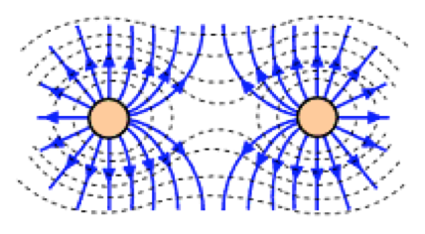

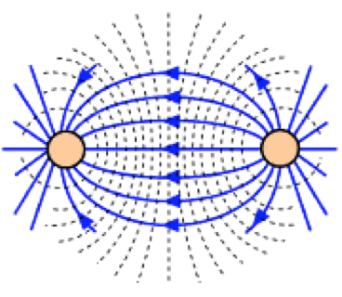

2. Calculate the number of electrons in 1.00nC of charge? [2 marks]

3. The colour that shows on the touch screen of most modern mobile devices is determined by the charge that is delivered to the pixel. The charge specification for colour pixels of an iPhone or iPad tablet is shown in the table below.

 | Red | 0.4pC
 | Yellow | 0.8pC
 | Blue | 1.2pC
 | Violet | 1.6pC

If a high energy cosmic particle with a charge equivalent of 7.50 million electrons strikes the touch screen, what colour pixel will be seen? Use calculations to explain your answer. Note: no marks will be given for guessing. [5 marks]

4. A charge of 4μC placed inside an electric field experiences a force of 0.12N. Calculate the electric field intensity. [3 marks]

5. An alpha particle (He²⁺) with a mass of 6.40x10⁻²⁷kg is placed in a uniform electric field of strength 50NC⁻¹. Calculate the acceleration of the particle inside the field region. [4 marks]

6. What potential difference is required between two electrodes in an electron gun to accelerate an electron from rest to a speed of 10⁶ms⁻¹? [4 marks]

7. Consider the following parallel plate arrangement.

- Complete the diagram showing the electric field that exists between the plates.  [1 mark]  - Draw an electron situated between the plates and the forces acting on it.  [1 mark] | 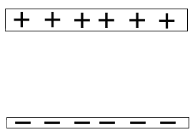

- Calculate the electric field strength if the plates are 1cm apart and connected by a 12volt battery. [1 mark]

- What voltage would have to be placed onto the plates for the electron to hover in the one spot between the plates? [3 marks]

8. One tiny metal ball carries a charge of +3nC and a second ball, with identical shape, size and electrical properties, has a charge of -12nC. What force exists between the charges if they are placed 30mm apart? [4 marks]

9. A girl finds that her clothes are clinging together when she takes them from the hot air dryer. She finds that she needs to exert a force of 0.50N to pull the clothing apart. If we assume that the charges on the pieces of clothing is equal and that they are 0.8mm part. Calculate the charge being carried by each piece of clothing. [4 marks]

10. A nucleus of lead with a mass of 3.45x10⁻²⁷kg, is fired horizontally between two parallel plates that are 4cm apart, with a speed of 0.75c. If the plates are 15cm long, and the potential difference across the plates is 50kV, does the lead ion emerge on the opposite side of the plates? Note: all working must be shown. [10 marks]

11. Charged particles move in a circular path when travelling through a magnetic field.

- By equating the centripetal force and Lorentz force experienced by the particle, show that the radius of the resultant circle is directly proportional to the momentum of the particle. [3 marks]

- A beam of particles with a charge of -1 is beamed across a magnetic field of strength 2.50x10⁻² T. The beam bends into a circular path of radius 22cm. If the particles are moving at 2.30x10⁴ ms⁻¹, determine the mass and identity of the particles. Hint: 1amu = 1.6606x10⁻²⁷kg [4 marks]

12. An alpha particle enters a velocity selector with magnetic field of strength 3.70x10⁻² T and at a velocity of 3.50x10⁵ ms⁻¹.

- What is the charged carried by the alpha particle? [1 mark]

- What is the electric field experienced by the alpha particle? [2 marks]

- The alpha particle leaves the velocity selector (travelling to the right) and enters a mass spectrometer with a uniform horizontal magnetic field strength of 2.50x10⁻²T, into the page. Calculate the force the magnetic field exerts on the particle as it passes through the mass spectrometer. [3 marks]

- In the space provided below, draw the path of the alpha particle, as well as the path an electron would take. [2 marks]

⊗
⊗
⊗
⊗
⊗

